**Project Report on**

**Credit Card Segmentation**

**Submitted by:**

**OmPrakash Sah Kalwar**

# edWisor E-learning

**Gurgaon, Haryana**

**DECLARATION**

I, OmPrakash Sah Kalwar, student of B.E Batch 2020 passout of CMR Institute Of Technology, Visvesvaraya Technological University, Aecs Layout, Kundhanahalli gate, Banglore-560037 declares that Project Report on Credit Card Segmentation submitted and is the original work conducted by me.

The information and data given in the report is authentic to the best of my knowledge.

OmPrakash Sah Kalwar

Place: Banglore-560037

**Content**

**Topic** **Page**

**Introduction** 4-12

**Research Methodology** 13-20

**Conclusion**  20-21

**Summary** 21-21

**Reference** 22-22

**INTRODUCTION**

Since the 1980s, credit card usage has soared all around the world. The convenience and safety of not carrying cash, the possibility of paying in installments, non price benefits like bonuses, rewards, and shopping miles, and quick and easy access to credit are among the factors that contributed to the widespread adoption of credit cards by consumers. There has been a significant increase of credit card usage in India. As the credit card network spreads and more persons get into its ambit, customer service in its business gains further importance. The present trend indicates that the coming years will witness a burgeoning growth of credit cards which will lead to a cashless society.

Credit has become an important vehicle of trade promotion. Credit cards provide convenience and safety to the buying process. One of the important reasons for the popularity of credit cards is the sea change witnessed in consumer behaviour. Credit cards enable an individual to purchase products or services without paying immediately. The buyer only needs to present the credit cards at the cash counter and sign the bill.

Credit card can, therefore, be considered as a good substitute for cash or cheques. A credit card is a card establishing the privilege of the person to whom it is issued to charge bills. Most retail firms accept credit cards. Credit cards allow consumers to make purchases without paying cash immediately or establishing credit with individual stores. They eliminate the need to check credit ratings and to collect cash from individual customers.

The issuing institution establishes the card’s terms, including the interest rate, annual fees, penalties, the grace period, and other features. Credit card debt is typically an unsecured debt. Repossession is not easily accomplished by the lender to ensure payment. Banks have often priced the product assuming maximum risk exposure. This chapter contains information on credit card system, credit card operating cycle, credit card defaults, consequences.

Of credit card default and need for the study.

1.1 Credit card system

1.2 Credit card operation cycle

1.3 Credit card defaults

1.4 Consequences of credit card defaults

1.5 Need for the study

1.1 CREDIT CARD SYSTEM

1.1.1 Interest charges

Credit card issuers usually waive interest charges if the balance is paid in full each month, but typically will charge full interest on the entire outstanding balance from the date of each purchase if the total balance is not paid. The credit card may simply serve as a form of revolving credit, or it may become a complicated financial instrument with multiple balance segments each at a different interest rate, possibly with a single umbrella credit limit, or with separate credit limits applicable to thevarious balance segments. Interest rates can vary considerably from card to card, and the interest rate on a particular card may jump dramatically if the card user is late with a payment on that card or any other credit instrument, or even if the issuing bank decides to raise its revenue.

1.1.2 Grace period

A credit card's grace period is the time the customer has to pay the balance before interest is charged to the balance. Grace periods vary, but usually range from 20 to 50 days depending on the type of credit card and the issuing bank. Some policies allow for reinstatement after certain conditions are met. Usually, if a customer is late paying the balance, finance charges will be calculated and the grace period does not apply. Finance charges incurred depend on the grace period and balance, with most credit cards there is no grace period if there is any outstanding balance from the previous billing cycle or statement (i.e. interest is applied on both the previous balance and new transactions). However, there are some credit cards that will apply finance charge only on the previous or old balance, excluding new transactions.

1.1.3 Benefits to customers

Because of intense competition in the credit card industry, credit card providers often offer incentives such as frequent flyer points, gift certificates, or cash back (typically up to 1 to 5 percent based on total purchases) offers try to attract customers to their programs. Low interest credit cards or even 0 per cent interest credit cards are available.

1.1.4 Benefits to merchants

For merchants, a credit card transaction is often more secure than other forms of payment, such as cheques because the issuing bank commits to pay the merchant the moment the transaction is authorized, regardless of whether the consumer defaults on the credit card payment. In most cases, cards are even more secure than cash, because they discourage theft by the merchant's employees and reduce the amount of cash on the premises. Prior to credit cards, each merchant had to evaluate each customer's credit history before extending credit. That task is now performed by the banks which assume the credit risk.

1.2 CREDIT CARD OPERATION CYCLE

The credit card operation comprises the following steps as follows:

i. Credit purchases: A Cardholder purchases goods/services and gives the credit card.

ii. Processing of credit card: A Merchant establishment delivers goods after taking an authenticated credit card and noting the number and taking signatures on certain forms.

iii. Raising of bill: The Merchant establishment raises the bill for the purchase and sends it to the credit card issuing bank for payment.

iv. Marking payment: The issuing bank pays the amount to the merchant establishment.

v. Bill to cardholder: The issuing bank raises bill on the credit cardholder and sends it for payment.

vi. Card Payment: The credit cardholder makes the payment to the issuing bank.

The following important parties involved in the operation of credit cards are:

Credit cardholders: The person named on the card. This may be customer of a bank to whom the card has been issued or any such person to whom the bank has issued a card authorized by the customer of the bank to hold and use the card. This individual is also responsible for payment of all charges made to that card. The holder of the credit card who uses to make a purchase is called the consumer.

Card-issuing bank: The financial institution or other organization that issued the credit card and also responsible for billing the cardholders for charges. The bank bills the consumer for repayment and bears the risk that the card is used fraudulently. The issuing bank extends a line of credit to the consumer. Liability for non-payment is then shared by the issuing bank and acquiring bank.

Merchant Establishments: The individual or business accepting credit cards or sold products or services to the cardholders.

Acquiring bank: The financial institution accepts payment for the products or services on behalf of the merchant establishments.

Independent sales organization: Resellers (to merchants) of the services of the acquiring bank. i.e. outside services providers for marketing of cards.

Merchant account: This could refer to the acquiring bank or the independent sales organization, but in general is the organization that the merchant deals with.

Credit card association: An association of card-issuing banks such as Visa, MasterCard, Discover, American Express that set transaction terms for merchants, card-issuing banks, and acquiring banks.

Transaction network: The system that implements the mechanics of the electronic transactions. May be operated by an independent company, and one company may operate multiple networks. Transaction processing networks include Cardnet, Nabanco, Omaha, Paymentech, NDC Atlanta, Nova, Vital, Concord EFSnet, and Visa Net.

Affinity partner: Some institutions lend their names to an issuer to attract customers that have a strong relationship with that institution, and get paid a fee or a percentage of the balance for each card issued using their name. Examples of typical affinity partners are sports teams, universities, charities, professional organizations, and major retailers.

1.3 Credit card defaults

Credit card default happens when you break the terms and conditions of your credit card. When you accept your credit card, you agree to certain terms. For example, you agree to make your minimum payment by the due date on your credit card statement. If you pay less than the minimum or you don’t make your payment by the due date, you are in credit card default. Going over your credit limit and having your payment returned by your bank are also types of credit card default. The three new financial variables which we find to have the most significant impact on default are:

(1) the ratio of total minimum required payment from all credit cards to household income;

(2) the percentage of total credit line which has been used by the consumer;

(3) the number of credit cards on which the consumer has reached the borrowing limit Credit card default results in additional fees and sometimes an interest rate increase. You may be able to have some credit card default fees reversed if you ask your credit card issuer.

You’re more likely to have these fees waived for first time offenses. When your interest rate increases to the default interest rate, it can only remain there for six months. After six months, your credit card issuer is required to review your account and lower your rate as long as you haven’t redefaulted within the past six months. The proliferation of credit cards and their ease of access have given consumers increased opportunities for making credit purchases. However, while many consumers are able to use credit cards wisely, others seem to be unable to control their spending habits. Credit card companies find college students attractive because, although their current income is low, they have potential to earn much higher incomes in the near future. Also, the college student lifestyle offers many opportunities to use credit cards – both as a convenience and as a short term loan – for things such as emergency car repair, a weekend trip, and internet purchases. Expansion of the credit card market to college students has led to credit cards becoming a way of life for today’s college student.

While the research to date on credit card default has provided valuable information about trends in this market, lack of detailed data has limited the understanding of consumer behavior and motivation in the use of cards and subsequently in a more complete understanding of default. Credit cards have become a ubiquitous financial product held by households in all economic strata in most countries. Governments and credit card issuing agencies have put in place laws and regulations to ensure that consumers have the protections and information they need to use this widely available form of open-end credit wisely. Nevertheless, concerns persist about whether consumers fully understand the costs and implications of using credit cards and whether credit cards have encouraged widespread over indebtedness. The credit card companies have also expanded quickly into the emerging markets in order to exploit the opportunities that are provided by the emerging markets. Credit card usage pattern of emerging markets also differs from those of well-developed markets in important ways. The factors that affect credit card usage pattern of consumers in emerging markets and the implications of these factors for developing marketing strategies may not be the same as those for well-developed markets.

Understanding the factors that explain consumer behavior of credit card users in emerging markets could provide an essential insights to marketing strategists of financial services, retailers, and businesses in promoting use of credit cards. The consumer credit card market is reaching the saturation point, so the industry needs to develop marketing strategies that appeal to changing customer needs in order to encourage credit card usage, especially for the BEMs Credit cards have become welcomed by the public because many people consider “buying today” with an option of “paying later” as a convenient way of obtaining instant gratification. In addition, a large number of credit card users believe there are certain advantages of paying by credit cards. For example, credit cards can “eliminate security problems in carrying cash,” they provide “convenience … as opposed to a personal check, ease of borrowing money,” and they “serve as a record of purchase, and meeting emergency needs” However, credit cards can also disadvantage consumers in many ways. For example, sometimes cardholders are charged high annual fees and high APRs when they borrow money from credit card companies. Consequently, these extra costs may jeopardize consumers’ economic situations. The increasing profitability of credit cards has encouraged card issuers to issue cards to consumers who do not have stable incomes and to people who were once believed not to be credit worthy or had bad credit histories.

Consequently, more people will have a chance to get involved in credit card debts. It is now reasonably well understood that unsecured credit such as credit card debt poses a common-pool problem. Since it is not secured by any collateral and since recoveries will be allocated pro rata under bankruptcy, each credit card issuer is motivated to try to collect from the “common pool” — and the attempt to collect by one issuer may pose a negative externality to other issuers. When a consumer becomes financially distressed, each credit card lender has an incentive to try to become the first to collect. For example, a lender may engage in aggressive collection efforts even if they may result in the consumer seeking protection under bankruptcy law: the benefits of collection accrue to this lender alone, while the consequences of a bankruptcy filing are distributed over all credit card lenders and other creditors.

1.4 consequences of credit card default:

1. Your account will be 30, 60, and 90 days late After you don’t pay your first credit card bill it will be 30 days late, 60 days for the next billing cycle, and 90 days for the cycle after that. Many wrongly conclude that “30 days late” means you are paying 30 days after the due date… that’s not correct. Days 1 through 30 after your due date are all classified as 30 days late (but most banks won’t report a late payment if it’s received during the first week or two after the due date). As you can guess, the credit score consequences become exponentially worse with each tier. Having a 30 or 60 day payment will definitely wreck havoc on your credit, but once you get to 90 days the consequences are really going to hurt.

2. Your account will be late 120 days, 150 days, or charged off Eventually your account will be charged-off; the bank will write it off as bad debt. Now when that happens may vary depending on the credit card company – not every bank will wait ’til after 120 or 150 days. Until the debt has been charged off, you should have the ability to still make things right and pay off the full amount and avoid the credit card default consequences. The late payments will still be on your credit record (unless you negotiated otherwise) but those will be a lot better than having a credit card debt default. Regardless of your bank, in all 50 states the debt collection statue of limitations starts at 180 days, so it’s likely they will wait longer than 180 days to charge-off the account.

3. Your account will head to collections After the account has been charged off it will head off to collections – usually sold to a third-party collection agency. Aside from the credit score damage, this is one of the most frustrating credit card default consequences for many. Why? Because it usually involves a barrage of harassing phone calls and letters in the mail.

The Federal Fair Debt Collections Act dictates what a collections agency can and cannot do to you. Unfortunately, you hear stories all the time about the rules not being followed. Here are some things the collections agency is supposed to abide be: • You must be given 30 days to dispute the credit card default (they can’t just automatically assume it’s valid). If you are disputing it, that must be done in writing.

• If you have asked them not to, you can’t be called at inappropriate times (like 3 am) or at places you prefer not to be called (like at work).

• The debt collector is strictly limited in what they can say to family members, co-workers, etc. in the event they encounter them on the phone.

• If you ask them to stop communicating with you or to only communicate through your attorney, they must follow through with your wishes.

4. There might be the possibility of a lawsuit

This isn’t a common practice but it still is a possibility. If the collections process is unsuccessful a lawsuit may be filed. So what are the default consequences if a lawsuit is filed by the creditor? Well assuming the debt is valid (it’s really your debt) then odds are a judgment will be issued against you. If you were properly served the court papers and choose not to show up, the judgment can still be issued against you.

5. The effect of a credit card default on your credit

While wage garnishment, seizure of bank funds, and jail are things that only affect a very tiny sliver of those who default on credit card debt, there is one consequence you are 100% guaranteed to experience… the impact of the credit card debt default on your credit score.

The exact consequences a debt default will have on your credit depend on a few things:

• What was your credit like before defaulting? If you already had bad credit beforehand (perhaps you already had a bad debt) then the impact will be less noticeable. After all, “bad credit” and “really bad credit” are more or less looked upon in the same way by banks these days.

• One or multiple credit cards defaulted? Did you default on one of your credit cards or all of them? Having one credit card default will probably have less of an impact than having charge- offs on multiple credit cards.

• What was the amount of the default? Whether your default was $10 or $10,000 it is going to hurt your credit significantly. However, the higher the amount is in relation to your other accounts, the more of an impact it might have.

1.5 Need for the study

The study is basically conducted to evaluate the perception of the credit card customers and issuing banks. This study has its own advantages and disadvantages; it is worthwhile therefore, to consider all the aspects.

In the backdrop of this the present study was undertaken with the following objectives:

1) To study the perception of credit card customers regarding credit card defaults .

2) To study the perception of issuing banks regarding credit card defaults

**Research Methodology**

To achieve the proposed objectives of the study, Primary data regarding credit card defaults will be collected from issuing banks and credit card customers.

The chapter has been divided under the following heads:

• Research design

• Population

• Statistical tools used

Research design

For the purpose of this research, exploratory research design is used. Questionnaires were used to achieve the objectives of the research.

For the achievement of the objective, a questionnaire was designed for the customers, which would help in finding out the general perception of the customers regarding credit card defaults.

Population

The population includes all the people using credit cards.

Statistical tools used

Used necessary libraries and Machine Learning libraries also.

Uses of Libraries:

* A *library* is a collection of files (called *modules*) that contains functions for use by other programs.
  + May also contain data values (e.g., numerical constants) and other things.
  + Library’s contents are supposed to be related, but there’s no way to enforce that.
* The Python [standard library](https://docs.python.org/3/library/) is an extensive suite of modules that comes with Python itself.

We obtain the mean payment_minpayment ratio for each purchse type:

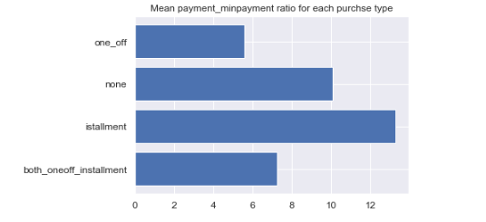

Dataframe are describe:

By determining the

–mean

-Standard Deviation

-minimum value

-25%

-50%

-75%

-maximum

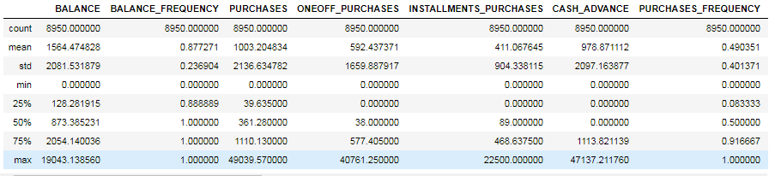

Use of Machine Learning:

Segmentation in marketing is a technique used to divide customers or other entities into groups based on attributes such as behaviour or demographics. It is useful to identify segments of customers who may respond in a similar way to specific marketing techniques such as email subject lines or display advertisements. As it gives businesses the ability to tailor marketing messages and timing to generate better response rates and provide improved consumer experiences.

In the following post, I will be using a dataset containing a number of behavioural attributes for credit card customers. I will be using python machine learning library to apply an unsupervised machine learning technique known as clustering to identify segments that may not immediately be apparent to human cognition.

The dataset consists of 18 features about the behaviour of credit card customers. These include variables such as the balance currently on the card, the number of purchases that have been made on the account, the credit limit, and many others.

Some Machine Learning Libraries used are:

import statsmodels.api as sm

from sklearn import metrics

from sklearn.model_selection import train_test_split

from sklearn.linear_model import LinearRegression

from sklearn.ensemble import RandomForestRegressor

from sklearn.tree import DecisionTreeRegressor

**Checking if there is any null values in data frame:**

Missing value treating by inputing them with median

credit.isnull().any()

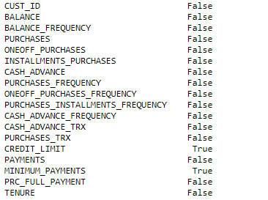

* False says that there is no null values and true shows that there is present of null characters.

This null values are removed using median to get the correct result.

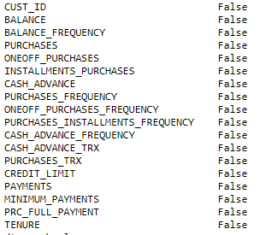

See now all the null values are removed.

We have calculated the:

* Monthly_cash_advance Amount
* Monthly_avg_purchase
* counting zeros in ONEOFF_PURCHASES
* Purchases by type (one-off, installments)

to achieve the requirement for credit card segmentation.

Finding customers ONEOFF_PURCHASES and INSTALLMENTS_PURCHASES details. As per above detail we found out that there are 4 types of purchase behaviour in the data set. So we need to derive a categorical variable based on their behavior. Limit_usage (balance to credit limit ratio ) credit card utilization Lower value implies customers are maintaining thier balance properly.

Lower value means good credit score.

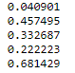

Average cash advance taken by customers of different Purchase type : Both, None,Installment,One_Off

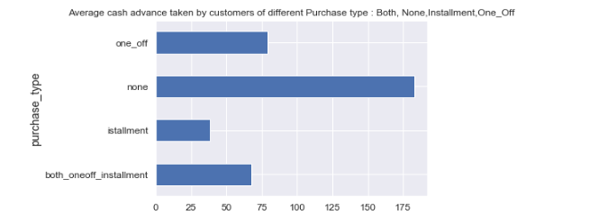

Customers who don't do either one-off or installment purchases take more cash on advance

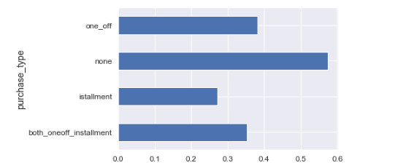

Preparing Machine learning algorithm. We do have some categorical data which need to convert with the help of dummy creation. Creating Dummies for categorical variable, Now merge the created dummy with the original data frame.

Python is a great language for doing data analysis, primarily because of the fantastic ecosystem of data-centric python packages. Pandas is one of those packages and makes importing and analyzing data much easier.

Pandas**dataframe.corr()** is used to find the pairwise correlation of all columns in the dataframe. Any na values are automatically excluded. For any non-numeric data type columns in the dataframe it is ignored.

Heatmap is a way to show some sort of matrix plot. To use a heatmap the data should be in a matrix form. By matrix we mean that the index name and the column name must match in some way so that the data that we fill inside the cells are relevant.

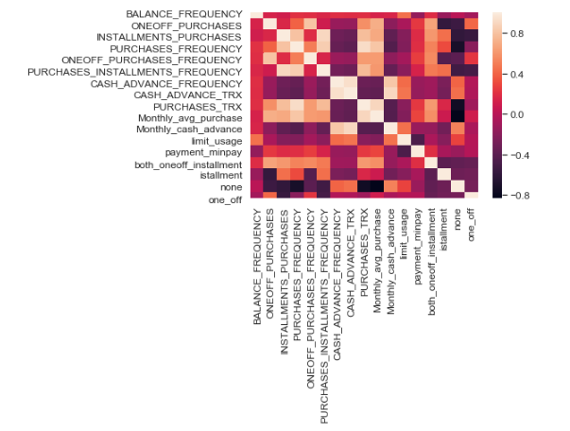

Standardrizing data to put data on the same scale. Applying PCA with the help of principal component analysis which we will reduce features. We have 17 features so our n_component will be 17. Lets check if we will take 17 component then how much varience it explain. Ideally it should be 1 i.e 100%. Since 6 components are explaining about 90% variance so we select 6 components. Since 5 components are explaining about 87% variance so we select 5 components.

So initially we had 17 variables now its 5 so our variable go reduced. So above data gave us eigen vector for each component we had all eigen vector value very small, we can remove those variable bur in our case its not. Factor Analysis : variance explained by each component. Clustering. Based on the intuition on type of purchases made by customers and their distinctive behavior exhibited based on the. Purchase_type (as visualized above in Insights from KPI) , I am starting with 4 clusters.We are using this library for importing cluster,

from sklearn.cluster import KMeans

Here we donot have known k value so we will find the K. To do that we need to take a cluster range between 1 and 21. Identify Cluster Error. It is very difficult to draw individual plot for cluster, so we will use pair plot which will provide us all graph in one shot. To do that we need to take following steps. Pairwise relationship of components on the data.

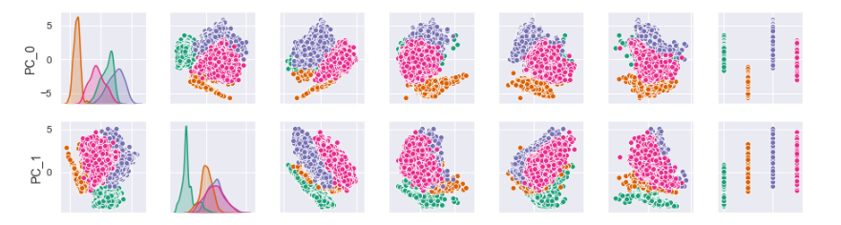………….etc

Now we have done here with priciple component now we need to come bring our .Original data frame and we will merge the cluster with them. To interprate result we need to use our data frame. Key performace variable selection . here i am taking varibales which we will use in derving new KPI. We can take all 17 variables but it will be difficult to interprate.So are are selecting less no of variables. Conactenating labels found through Kmeans with data. 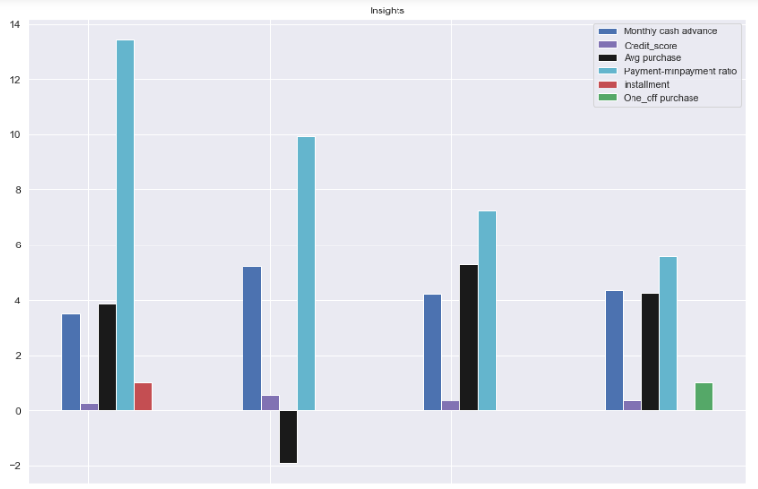

Clusters are clearly distinguishing behavior within customers. Percentage of each cluster in the total customer base. Finding Mean of features for each cluster. Finding behavior with 6 clusters. Checking performance metrics for Kmeans. I am validating performance with 2 metrics Calinski harabaz and Silhouette score.The above methodology is applied to visualize the data.

**CONCLUSION:**

Credit card is a facilitating instrument that enables its holders in general, and those who suffer from lack of liquidity, in particular, to buy their goods and services. The banks whose credit card being used never even ask for at least a third party guarantee for the transactions which may involve thousands of rupees. Technology brings both positive and harmful issues to the mankind. The developed and affluent countries are the pioneer to experience the outcome of technology.

The advent and expansion of plastic money has made the life of people much more comfortable. Day by day, the number of users of plastic money is increasing. The marketers are frequently redesigning their plastic money products to compete with their rivals as well as to provide better service to the consumers. The credit cards issue in terms of number of credit cards witnessed a high growth rate.

The credit facility and convenience in shopping has influenced the cardholders to select the credit cards. The frequency of usage among the respondents is higher in Departmental stores and shopping malls during festival seasons.

The banks should take efforts to widen the usage of cards by increasing the number of outlets accepting credit cards. The Merchant establishments should accept cards without prescribing the minimum limit of purchase by the customer within the credit limit. Further, the Merchant Establishments should treat the customers who make payments through card and cash on par.

**SUMMARY:**

The purpose of this study was to develop a better understanding of perception of the customers and issuing banks regarding various attributes and aspects relating to credit card defaults such as general reasons for credit card, repayment attitude of the customers, knowledge of the customers regarding credit card defaults and agreement with their banks, general reasons for denial of credit cards, time period of default While the research to date on credit card default has provided valuable information about trends in this market, lack of detailed data has limited the understanding of consumer behavior and motivation in the use of cards and subsequently in a more complete understanding of default.

This study aims at achieving the following objectives;

• To study the perception of credit card customers regarding credit card defaults

• To study the perception of issuing banks regarding credit card defaults

To achieve the proposed objectives of the study, Primary data regarding credit card defaults was collected from issuing banks and credit card customers using exploratory research design. Two questionnaires were prepared to achieve the objectives of the research; one for the customers and the other for the bank managers. Various attributes and aspects regarding credit card defaults such as general reasons for default, study of respondents’ knowledge regarding consequences of default and agreement with their banks, general reasons for denial of credit card, etc.

**REFERENCES**

Agarwal S, Chomsisengphet S and Liu C (2010) The importance of adverse selection in the credit card market: Evidence from randomized of credit cards solicitations. J Money,Credit and Banking 42:743-54.

Brito D L and Hartley P R (1995) Consumer rationality and credit cards. J Polit Econ 103:400-33.

Chien Y W and Devaney S A (2005) he Effects of Credit Attitude and Socioeconomic Factors on Credit Card and Installment Debt. J Conumer Affairs 35:162-79.

Chung S K and Suh Y M (2009) Estimating the utility value of individual credit card delinquents. J Expert Systems with Applications 36:3975-81